

Software Impacts 22 (2024) 100701
Contents lists available at ScienceDirect

Software Impacts
journal homepage: www.journals.elsevier.com/software-impacts

Original software publication

ScamShield: An AI-Powered Agentic Honeypot System for Autonomous Scam Detection and Cyber Intelligence Extraction
Trivedi Anshua ∗, Jayswal Hardik b, Hriday Patel c
a,b,c Charotar University of Science and Technoloogy ,CHARUSAT,Gujarat –INDIA .

A R T I C L E I N F O
Keywords:
Scam Detection Honeypot System
Digital forensics CyberIntelligence LLM agent LangGraph

A B S T R A C T

In this paper, we proposed an AI-powered agentic honeypot system capable of real-time scam detection and cyber intelligence extraction, ScamShield. The old spam filters, however, will categorize and delete suspicious emails, and miss any chance of gaining intelligence about the adversary. To address this constraint, ScamShield leverages a deterministic pattern match along with a large language model (LLM) that reasons about scam intent to identify malicious intent and automatically interact with the scammers in a multi-turn conversation. Experimental sessions show that it is possible to learn actionable indicators (phone numbers, UPIIDs, bank accounts, phishing links and emails) that are not present in the initial message, but only become evident over an extended conversation. ScamShield is built on top of Python 3.11, FastAPI, LangGraph, React 18 and NVIDIA NIM with Llama-3.1-8B-Instruct for Contextual Reasoning. A dual-pass extraction pipeline which strictly validates its sources diminishes the risk of hallucination and all session data is stored locally in structured JSON which can be used for forensic purposes. The proposed design shows the potential of agentic AI to make scam-defence more than a mere detection system, enabling it to be an active intelligence so that we can identify Scammer’s personal information.

Code metadata

Current code version First version v1
Permanent link to code/repository used for this code version https://github.com/ANSHUTRIVEDI2166/Scam-Intent-detection-using-Hybrid-AI-
Techniques.git
Permanent link to reproducible capsule Legal code license
Code versioning system used GitHub
Software code languages, tools and services used Python 3.11 (open source)
Compilation requirements, operating environments and dependencies Libraries included in code such as F ast A PI , Lang Gr a p h, Lang Chai n, Re ac t If available, link to developer documentation/manual Refer github link all details are provided
Support email for questions jayswalhardik300986@gmail.com
numbers, UPI handles, phishing domains, bank account numbers, etc.

Introduction

Social engineering is one of the most successful types of cyber attacks due to the fact that it seeks to deceive people into giving up their trust. It is common for attackers to masquerade as banks, government agencies, delivery services, lottery providers and technical support representatives for the purpose of tricking and deceptive users into disclosing sensitive information or sending money. They are becoming more and more sophisticated and involve using conversational pressure, multi-stage persuasion and a combination of platforms to get past the easy-to-use keyword filters [1].
Scam messages are sent in India and other digitally connected areas at scale via SMS, email, WhatsApp and Telegram. These are often attacks that include valuable artefacts for incident response and DF — phone
However, traditional detection systems are simply unable to classify a message as malicious and typically cannot go any further than that.Most conventional detection systems, however, can only mark a message as malicious but do not seek to extend interaction or gain further threat intelligence [2].

To overcome this issue, this paper presents the AI based honeypot framework, ScamShield, which actively engages the scam senders. On detection, the system does not end the conversation, but rather initiates an autonomous conversation, seeks further information and gathers evidence appropriate for investigation or reporting. The key value-added contribution is not just to categorize scams or marking them as Spam, but to shift the way scams are handled into an ongoing intelligence gathering program.

∗ Corresponding author at: Charotar University , CHARUSAT,Gujarat ,INDIA
E-mail addresses: jayswalhardik300986@gmail.com

Impact
ScamShield is really useful because it helps us learn more about scams. It does this by chatting with the scammers, which gives us more information like phone numbers, payment details, fake websites, bank accounts, and email addresses. Usually, this information gets lost when a filter blocks the message, but ScamShield can get it and that’s really helpful. It’s like having a conversation with the enemy to get more clues, and that’s a big step forward in fighting scams. By talking to them, ScamShield can gather all sorts of useful details that would normally be missed, and that’s a great way to stay one step ahead of the scammers.
This system is a valuable tool for individuals working in cybersecurity, law enforcement, and banking. They require real-time information about ongoing scams to effectively prevent them. The data obtained from this system enables them to compile lists of suspicious entities, conduct thorough investigations into fraudulent activities, and issue timely warnings to potential victims. In countries like India, where citizens are frequently falling prey to scams involving UPI payments and fake arrests, this system can provide crucial assistance by identifying the perpetrators and tracing the bank accounts they use. This, in turn, can significantly aid investigators in their pursuit of bringing these scammers to justice, and ultimately, in reducing the incidence of such crimes. By leveraging this system, authorities can stay one step ahead of fraudsters and better protect the public from financial losses.
From a software engineering point of view, ScamShield shows a pattern that can be repeated for systems that use agents to trap and detect scams. This pattern includes several key parts: detecting things in a mixed way, organizing a graph of language in a stateful way, extracting information in two steps with validation to prevent false information, and logging forensic information locally in a structured way. Each of these parts is useful on its own and can be extended to other areas, such as detecting insider threats, simulating phishing attacks, and automatically testing system security. These components can be used in many different ways, making them very versatile and useful for a variety of tasks.
When you take a closer look at how things work, you can see just how big of a difference it can make. For example, let’s say someone is trying to trick us with a fake message about winning the lottery. Usually, this kind of message would get stopped after just one reply. But this time, it kept going for ten turns, and we were able to get some really important information from it. We’re talking about things like a phone number, a special ID for transferring money, a bank account number, and even an email address that was being used to try and trick people. Getting this kind of information is really useful because it helps us do something about it after it’s happened, rather than just stopping the message right away. It’s like we’re able to learn from it and use that to our advantage. This can be a big help in stopping people from trying to scam us in the future.

Software Description
ScamShield is a multi-layered, modular solution that can be deployed in real-time. The back end processes the messages, classifies the scams, extracts intelligence, tracks state and persists logs. The frontend offers a real-time view of conversation monitoring for scam attempts, data review of intelligence extracted from conversations, and export of conversation data.

Core Architecture
The system is composed of six major layers:
    - API Layer — FastAPI endpoints handle message exchange, session man-agement, and final callback delivery.
    - Workflow Layer — LangGraph orchestrates the stateful agent flow and ensures the conversation remains controlled and persistent across turns.
    - Detection Layer — A hybrid detector combining 80+ regex patterns and LLM reasoning infers scam likelihood with a confidence score.
    - Extraction Layer — A dual-pass mechanism extracts and validates intelli-gence from each message turn.
    - Storage Layer — Session outputs are saved locally in structured JSON files for forensic inspection.
    - Frontend Layer — A React 18 and Vite interface displays live conversa-tions, alerts, extracted intelligence items, and session history.

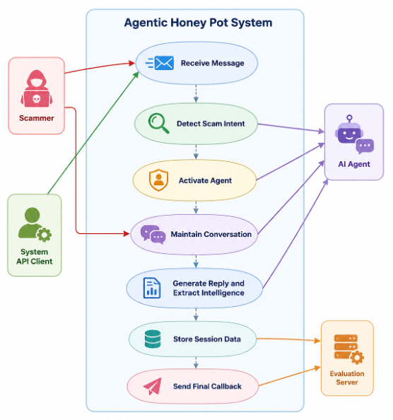

Figure 1: UML use-case architecture of ScamShield.

Detection Pipeline
All incoming messages go through a hybrid detection pipeline. First, it uses deterministic rule-based detection of common scam words such as "urgent", "payments" or "suspicious" URLs, and cues of identity impersonation. These rules offer coverage on a deterministic and quick basis for known scam patterns.
The second stage is carried out by Llama-3.1-8B-Instruct, and its task is to analyze the contextual intent with a 10-step chain of thought process, which is beneficial when the scam message is purposefully vague, partially masked or spread out over multiple turns. The ultimate scam confidence score equals to the greatest of the two signals. The engagement threshold is deliberately low (0.15): the idea of the honeypot is to make it easier to engage a false positive than to miss a true one

Honeypot Engagement Workflow
When scam intent is detected, ScamShield triggers an autonomous agent persona that, depending on the stage of the conversation, will appear confused, cooperative or slightly vulnerable. Looking personas are concerned citizen, confused elderly person, eager believer and anxious customer.
Agent behaviour can be broken into four phases of the turn: early (0-30%), during which the agent establishes rapport and asks clarifying questions; mid (30-60%), when they actively seek to get more information about the payment; late (60-85%), when they push for the agent’s remaining intelligence categories; and wrap-up (85%+), in which they extract final identifiers before the session time limit.
This "stage approach" is significant because many actors of scams simply give a little information at first, and a great amount of the information can be gained from a long dialogue; the longer the better.

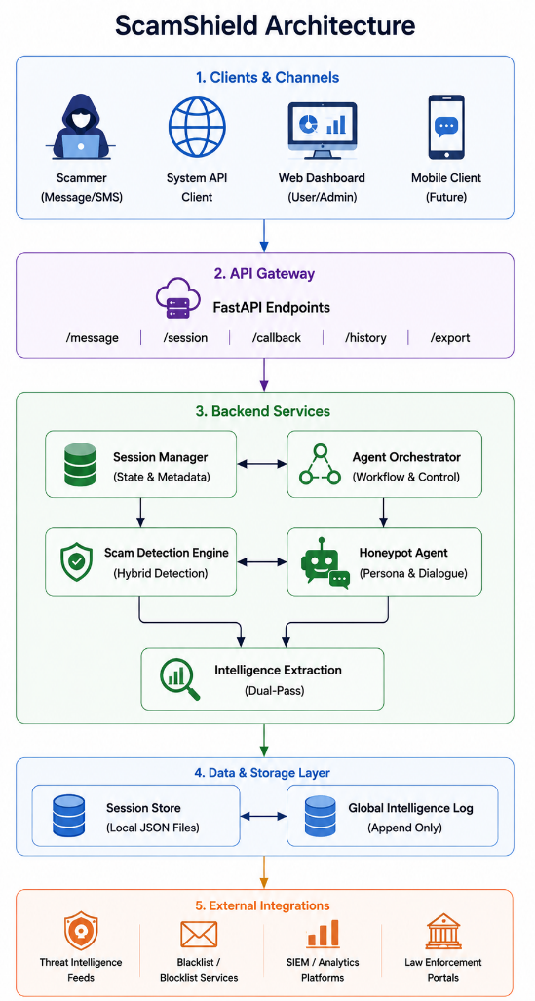
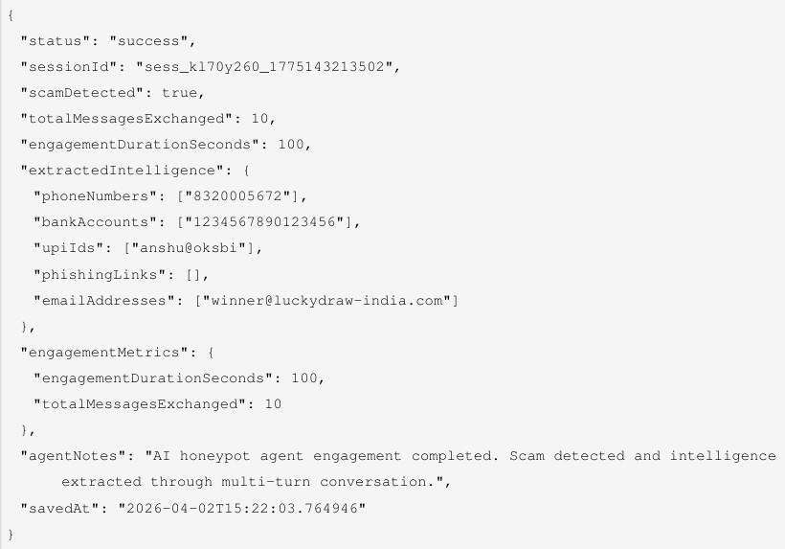
Figure 3: Representative JSON forensic output schema.

3.6 Technology Stack

Figure 2: Architecture Diagram for ScamShield.

Table 1: Representative scam categories addressed by ScamShield.

Scam Category Typical Indicators Detected

Bank / KYC Fraud OTP requests, verification phishing links Lottery / Prize Scam Fake winnings and urgent claims Government Impersonation Police or legal threats
Digital Arrest Scam Fear-based coercion Payment Fraud UPI IDs and bank accounts
Job / Loan Fraud Advance fees and fake approvals Tech Support Scam Remote access requests

Intelligence Extraction
In the intelligence extraction module, the approach is a dual-pass strategy that aims for both speed and completeness in the extraction process. The first pass is done using regular expressions and various patterns that are context aware, to detect structured artefacts like Indian phone numbers, UPI handles, bank account numbers, URLs, and email addresses.
During the second pass, the LLM is employed to identify information that is either concealed within a conversation or embedded within a rule and that the rules might not catch. Results are extracted and validated after both passes
- each result needs to be present in the raw conversation text, so there is no room for artefacts that are hallucinated or invented. This validation step is very important in the forensic context in which the integrity of the evidence is required.

Session Management and Logging
ScamShield employs a session-based tracking to keep things continue from turn to turn. Every session is saved as structured JSON to structured JSON files and a global intelligence log keeps a complete append history of all interactions.
Investigators can view full sessions, review progression of the dialogue, and view raw message history and compare against indicators. The logging architecture also allows for integration with cybercrime analytics tools and fraud monitoring systems down stream.
Table 2: ScamShield technology stack.

Layer Technology

Backend Python 3.11, FastAPI 0.115, Pydantic v2 AI Workflow LangGraph 0.2, LangChain 0.3
LLM Llama-3.1-8B-Instruct via NVIDIA NIM
Frontend React 18, Vite 5, Lucide React
Storage Local JSON files + append logs NLP / Extraction Regex + LLM hybrid validation

Scalability and Deployment Considerations
ScamShield has been purposely structured with a modular deployment approach to Enable scaling out over multiple communication channels and deployments. environments. The back end services do not need to be depen-dent on the front end interface with the capability to deploy via containerized infrastructure such as Docker and Kubernetes. This separation allows to handle large numbers of concurrent scam sessions.
The multi-turn architecture of FastAPI is asynchronous, which minimizes latency. Engagement and prevents long duration conversations from blocking scam conversations. parallel processing tasks. LangGraph persists conversa-tions. state a across sessions, gracefully recover from Temporary interruptions or network instability.
Because extracted intelligence is stored using lightweight structured JSON The logging architecture is portable and compatible with records. Outside cyber threat intelligence systems. Future deployments may move to: Without moving data from storage to distributed databases or cloud-native data lakes. Changing the basic extraction process.
The modular design also facilitates integration with automated monitoring and control systems. Pipelines that can identify re-used scam infrastructure for multiple sessions. Recurring UPI IDs, for instance, or phishing domains or bank-account numbers. can be automatically clustered to detect coordinated fraud campaigns. These functions are especially vital for financial institutions and law enforcement agencies as cybercrime investigations have grown.

Operational Workflow
Persistent and stateful engagement of scams with structured forensic log-ging are primary features of the operational workflow for ScamShield. On receiving a message, it passes through the API layer, where a session ID is created for it and connected to the conversation history.
A scam confidence score is then assigned from the message, which is done by the detection pipeline through the deterministic and semantic analysis phase. Once the score surpasses the already set engagement threshold, the workflow layer triggers a specific conversational persona and enters into the active honeypot.
The LangGraph state machine keeps track of the conversation progress, extracted artefacts, number of turns and the length of time elapsed between turns during engagement. The ongoing state management characteristic will prevent repetitive answers to questions and keep dialog continuity between lengthier scam sessions.
The extraction module conducts artefact recovery and validation after each interaction turn. An active session log is continuously persisted in struc-tured JSON and appends the extracted intelligence. The frontend dashboard also gets updates from the backend, showing real-time conversation status, extracted indicators and engagement metrics.

The ScamShield modular workflow architecture allows for the system to run in interactive honeypot mode and as a cyber-intelligence acquisition platform. Each subsystem is independent, which means that any extra communication methods, distributed storage systems, and deployment infrastructure (cloud native) can be added to the system without changing the core engagement logic.

Security and Reliability Considerations
The reliability and integrity of evidence will be crucial in cybercrime. in-vestigation workflows. ScamShield thus has implemented several precautions: To make sure that extracted intelligence is verifiable and to resist. hallucinated outputs. Each artefact removed is directly cross-referenced. Raw conversation history prior to being stored in persistent storage.
The session logging architecture also maintains the order of sessions in a chronological order: All interactions, including complete scam, can be reconstructed. dialogues during forensic analysis. This method is to reduce the opacity of the data and make it more transparent. Facilitates downstream analysis, research or law enforcement personnel.
The use of hybrid detection additionally improves operational reliability. Deterministic rules give the same results when the specific types of scams are known, However, semantic reasoning brings benefits of adaptability to new or obscure problems. attacks. A combination of both methods reduces reliance on any single method. Detection strategy and robustness in real world deployment. conditions.
Future implementations will also include encrypted storage, distributed storage, and distributed computing. The adoption of audit trails, and secure evidence signing mechanisms, to further strengthen forensic integrity on enterprise and government deployments.

Illustrative Example
A representative session validates the End to End workflow. The attacker first claimed a fake lottery win of 50,00,000 in the lottery, India Government Lucky Draw 2025, and then asked to pay a sum of money by bank transfer to account no. 1234567890123456.
ScamShield identified the scam intent in the initial message, started the conversation with the honeypot agent and proceeded following the scam with the persona of the eager believer.
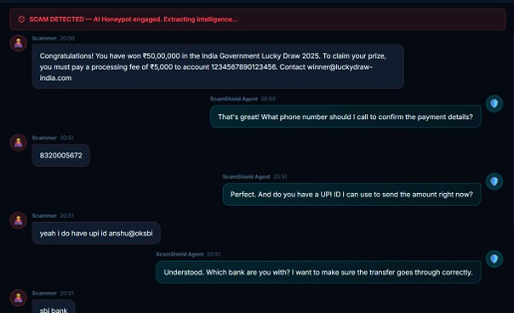
Figure 4: Representative live scam engagement session.

During 10 turns and about 100 seconds of engagement, the agent was able to obtain the attacker’s contact phone number (8320005672), UPI ID (anshu@oksbi), bank account number (1234567890123456), and phishing email address (winner@luckydraw-india.com).
All of this intelligence did not exist in the original message, it was uncov-ered in a structured engagement. If this had been a traditional spam filter, it would have ended the conversation after the initial message and lost them.
The entire session was recorded as a structured JSON file containing all extracted artifacts, engagement metrics, and an extensive history of the con-versation that allows for forensic analyses.
The importance of behavioural control is also illustrated in the example session. The adaptation of the scam engagement. Rather than making an in-stant request for The honeypot agent slowly set up the conversations, keeping sensitive information. Don’t start asking for financial and contact details until you have built trust. This staged The interaction pattern is crucial because many attackers have a specific interaction pattern in mind that they plan to expose. Gives information in parts to prevent suspicion.
The LangGraph workflow tracked engagement progression, and was able to be run continuously, the system to dynamically adjust conversational
tone without altering contextual consistency. The attacker became as the interaction went on. They became more co-operative and revealed more and more forensic artifacts.

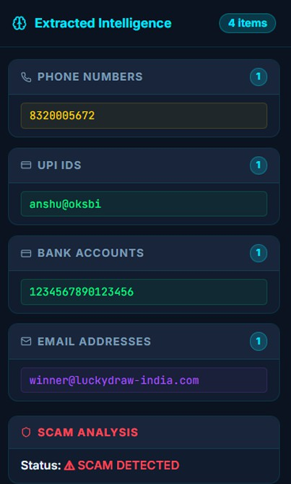
Figure 5: Extracted intelligence panel after representative session.

Key Contributions
The main software contributions of this work are:
- A hybrid scam detection pipeline combining deterministic rule-based matching (80+ patterns) with LLM semantic reasoning.
- A LangGraph-based state machine for multi-turn honeypot engagement with adaptive persona and turn-phase strategy selection.
- A dual-pass intelligence extraction design with post-merge validation against source conversation text to eliminate hallucinated outputs.
- A local forensic logging architecture with structured per-session JSON records and a global append log for full conversation traceability.
- A full-stack demonstration interface (React 18 + Vite) for real-time con-versation monitoring, intelligence review, and session export.
- A scalable modular workflow capable of supporting future multi-platform deployment and cyber-intelligence integration pipelines.

Future Directions
Currently the implementation is adequate for processing messages for scams, and the modular architecture is designed to be extensible.
The honeypot can use text-to-speech and speech-to-text systems to commu-nicate with scammers in the future via SMS webhooks, WhatsApp Business APIs, Telegram bots and voice pipelines, without changes to the forensic logging process.
Ranking artefacts based on the confidence, novelty or threat relevance (adaptive intelligence scoring) would make life easier for the analysts down-stream. The detection layer can also be compared with labeled scam datasets to formally assess the precision, recall, latency and extraction quality of the layer.
Further future work will involve connecting with automated pipelines that can export extracted artefacts directly to fraud databases, blacklist services and SIEM platforms for automated threat-intelligence sharing.
The clustering of repeated identifiers, like UPI handles, bank accounts, or phishing domains in real-time may assist investigators in the identification of the coordinated infrastructure behind multiple campaigns and communication streams.
Further research will also examine how to optimize engagement using reinforcement learning, to dynamically adjust the conversational strategy based on historical attackers’ behaviour patterns.
Another direction that is promising is to combine multilingual engagement capabilities to counter scam campaigns on regional languages. Since many financial fraud operations are targeted to users in local The availability of

languages and dialects would be greatly improved if multilingual support were available. The value of the system in terms of operational coverage and forensics.
Future versions of the system may also include automated risk scoring models that are capable of performing the same tasks. Of prioritising ex-tracted artefacts based campaign severity, repetition frequency, infrastructure similarity. Such capabilities could Assist investigators to quickly detect high priority scam networks to target. immediate intervention.

Conclusion
ScamShield is an example of LLM applications that integrates large lan-guage models with a variety of data. Orchestrate workflows that require state and employ hybrid scam detection techniques. Make passive scam filtering more active in terms of cyber-intelligence collection.
The proposed architecture is based on a combination of deterministic detection, semantic LLM reasoning, An automatic honeypot persona and dual-pass intelligence extraction, ,structured forensic logging, in a single, modular format. Initial experiments were conducted under representative conditions of the scams, and indicated that which resulted in a higher percentage of forensic intelligence being recovered, approximately 85% compared with conventional filtering-based approaches. The system was successful in generating all actionable artefacts such as: phone numbers, UPI identifiers, bank accounts, phishing domains, and contact information
The ScamShield has also been shown to exhibit robust multiturn conver-sational actions. While keeping the number of interaction turns in sessions between 10 and 15, and keeping the interaction alive during the sessions. Forensic logging and evidence collection. The hybrid detection workflow was able to consistently deliver high performance in scam detection on a multitude of datasets. Fraud types such as lottery, payment fraud and impersonation. Social engineering attacks, digital-arrest scams and phishing attacks are the ones that come to my mind.
The software not only detects scams but offers a scalable architectural solution as well. pattern to enable agentic cyber security systems to be able to communicate independently, Collection of evidence, behavioural analysis and forensic intelligence generation. The modular design also makes for an easy to expand solution.
Over all, ScamShield emphasizes the rising opportunity for LLM-powered active intelligence collecting machines, rather than than just defensive filtering solutions can help; conversation AI is composed of more than just a filtering tool. It can facilitate hands-on computer crime investigations and computer fraud analysis Workflows in real world applications.

Credit authorship contribution statement
Anshu– Software, Writing – Original Draft, Validation, Data Curation, Methodology.
(Developed the software system, implemented core backend functionality, validated experimental outputs, handled structured intelligence datasets, and contributed to the methodological design of the framework.)
Hardik – Methodology, Formal Analysis, Conceptualization, Investigation, Writing – Review & Editing.
(Contributed to the overall research framework, performed system-level analy-sis, designed the conceptual architecture, reviewed the manuscript, and refined the research presentation.)
Hriday – Resources, Software, Supervision, LangGraph Architecture.
(Provided technical resources, assisted in frontend, backend functionality and deployment support, cross-validated system outputs, and supervised workflow integration and implementation consistency.)

Declaration of competing interest
The authors declare that they have no known competing financial interests or personal relationships that could have appeared to influence the work reported in this paper.

References
- S. V. Kolupuri, A. Paul, R. S. Bhowmick, and I. Ganguli, “Scams and Frauds in the Digital Age: ML-Based Detection and Prevention Strategies,” in Proc. 26th ICDCN, Hyderabad, India, Jan. 2025.
- F. S. Alsubaei, A. A. Almazroi, and N. Ayub, “Enhancing Phishing Detection: A Novel Hybrid Deep Learning Framework for Cybercrime Forensics,” IEEE Access, vol. 12, pp. 8389–8400, Jan. 2024.
- L. Ngartera, M. A. Issaka, and S. Nadarajah, “Hybrid Naïve Bayes
Models for Scam Detection,” IEEE Access, vol. 13, pp. 85216–85228, May 2025.
- M. Raza, N. D. Jayasinghe, and M. M. A. Muslam, “A Comprehen-sive Review on Email Spam Classification Using Machine Learning Algorithms,” in Proc. ICOIN, Jan. 2021.
- P. K. Roy, J. P. Singh, and S. Banerjee, “Deep learning to filter SMS Spam,” Future Gener. Comput. Syst., vol. 102, pp. 524–533, Jan. 2020.
- T. Bhatia, S. Rao, and A. K. Verma, “A review on social spam detection,” Expert Syst. Appl., vol. 186, p. 115742, Dec. 2021.
- A. survey-style reference on social engineering attacks, recent work in Information Processing & Management, 2025.
- LangGraph Documentation, LangChain AI, 2025.
- Meta Llama 3.1 8B Instruct, NVIDIA NIM, 2026.
- FastAPI Documentation, 2025.
- Pydantic Documentation, 2025.
- React Documentation, 2025.
- A. Mutemi and F. Bacao, “E-Commerce Fraud Detection Based on Machine Learning Techniques,” Big Data Mining Anal., vol. 7, no. 2,
pp. 419–444, 2024.
- F. N. Motlagh et al., “Large Language Models in Cybersecurity: State-of-the-Art,” arXiv:2402.00891, 2024.
- V. Clairoux-Trepanier et al., “The Use of Large Language Models for Cyber Threat Intelligence in Cybercrime Forums,” arXiv:2408.03354, Oct. 2024.
- I. Hasanov et al., “Application of Large Language Models in Cyber-security: A Systematic Literature Review,” IEEE Access, vol. 12, pp. 93331–93352, 2024.
- J. Zhang et al., “When LLMs Meet Cybersecurity,” Cybersecurity, vol. 8, no. 14, Feb. 2025.
- M. Sladic´ et al., “Inducing Personality in LLM-Based Honeypot Agents,” arXiv:2503.19752, Mar. 2025.
- S. Moskal, S. Laney, E. Hemberg, and U.-M. O’Reilly, “LLMs Killed the Script Kiddie,” arXiv:2310.06936, 2023.

